Monoclonal Antibody Cross-Reactivity between Swine Influenza Hemagglutinins

Amanda Skarlupka’s Data Analysis Project

Amanda Skarlupka

2019-11-28

# Summary/Abstract

Although a vaccine for influenza exists, the efficacy and efficiency of the vaccine is very low and needs to be administered annually. Neutralizing antibodies are elicited from vaccination and are recalled during an infection. The Ross Lab at the CVI has developed a P1 hemagglutinin (HA) Computationally Optimized Broadly Reactive Antigens (COBRA) created with swine and human isolated H1 influenza HA sequences. Monoclonal antibodies specific for P1 HA were individually more broadly reactive against human isolated influenza than wild-type HA specific monoclonals. These monoclonals were tested for neutralizing activity against the swine isolated viruses. The P1 monoclonals and A/California/07/2009 monoclonals both reacted against swine viruses.

# Introduction

The majority of the surface of the influenza virion is composed of two glycoproteins: the hemaglutinin (HA) and the neuraminidase (NA). Upon vaccination the host responsed by producing neurtralizing antibodies targeting these surface proteins. Due to the high variablity and mutability of the HA, the influenza virus is able to undergo antigenic drift and evade vaccine induced protection. In the Ross lab, a cross-reactive HA protein vaccine has been developed. This computational HA (P1 COBRA HA) contains a broader set of antibody epitopes than wild-type HAs. To further investigate the renterence between the epitopes displayed on the P1 and the wild-type A/California/07/2009 (CA/09) HA, monoclonal antibodies raised against each antigen were purified and are currently undergoing characterization. It was found that the P1-specific antibodies bound to a wider range of human isolated influenza viruses, whereas the CA/09 antibodies were more narrow. However, influenza is also isolated from swine hosts, and swine influenza sequences were used in the design of the P1 COBRA HA immunogen. Therefore, the P1-specific antibodies may bind to more wild-type swine influenza HAs than CA/09 antibodies. The impact of a cross-species influenza vaccine is useful for animal-workers as well as prevention of a future pandemic.

The data contains 1.) the minimum hemagglutination inhibtion concentration of each purified monoclonal antibody from CA/09 or P1 COBRA, 2.) the hemagglutination inhibtion titer of the polyclonal sera from the mice that the monoclonal antibodies were purifed from, 3.) the HAs being tested are different swine influenza H1 viruses. There are 19 different swine viruses. There are 12 P1 Mabs, 18 CA/09 Mabs, 6 polyclonal sera from CA/09 mice, and 10 polyclonal sera from P1 mice.

I have generated the minimum inhibitory concentration data and the HAI titer data. The other data is classification data. The post-doc (Giuseppe) has determined the binding locations of the antibodies and whether they compete for similar epitope regions. Furthermore the swine viruses that are being tested for being inhibited can be categorized into different genetic lineages.

## Questions/Hypotheses to be addressed

Monoclonal antibodies raised against P1 COBRA HA immunogen show a wider-breadth hemagglutinin inhibtion among different influenza viruses than monoclonal antibodies raised against CA/09 HA. Furthermore, the minimum hemagglutin inhibition concentration of the antibodies is less than those elicited by CA/09. We would like to investigate if there are any discernable differences between the inhibtion of P1 antibodies and CA/09 antibodies. Do the P1 monoclonals have a wider breadth of binding to swine influenza? Are the responses different enough that we can use that data to predict based on the observed outcome if the antibody used was a P1 or a CA/09 antibody? We believe that the P1 monoclonals will have a binding to the swine viruses at least equivalent to the CA/09 monoclonals.

# Material and Methods

#### Monoclonal Antibody Production

The monoclonal antibodies used for the assays are described in Table 1.

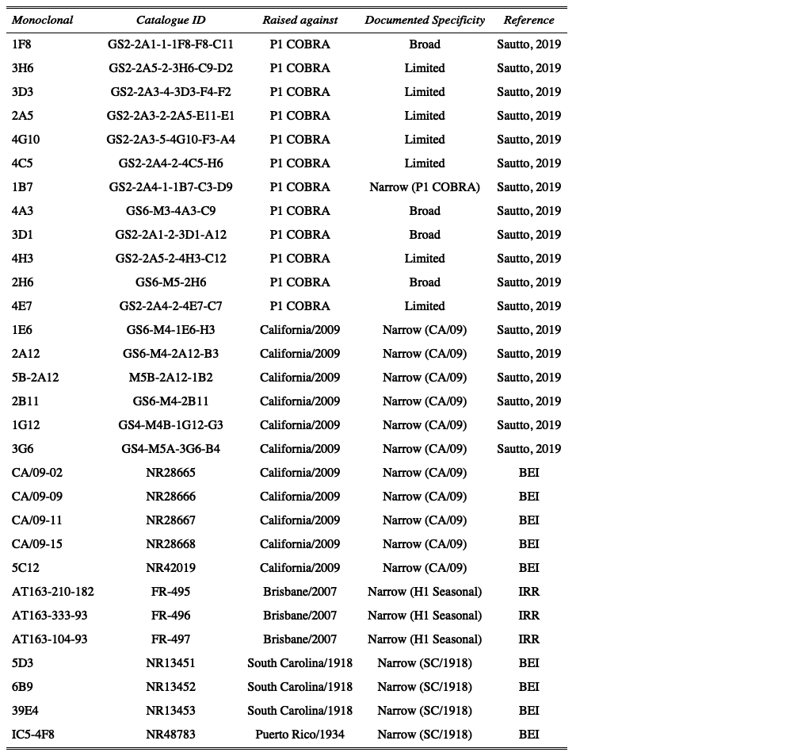

Figure 1: Table1.

#### Viruses and HA antigens

H1 viruses were obtained through the Influenza Reagents Resource (IRR), BEI Resources, the Centers for Disease Control (CDC), Sanofi-Pasteur, or the Tompkins Laboratory. Viruses were passaged once in the same growth conditions as they were received or as per the instructions provided by the WHO or the University of Minnesota, in either embryonated chicken eggs or Madin-Darby canine kidney (MDCK) cell culture. Virus lots were aliquoted for single-use applications and stored at -80°C. Hemagglutination titer of the frozen aliquots was determined with turkey RBCs.

The classification of the swine HA was determined using the Swine H1 Clade Classification Tool (<http://www.fludb.org>) and infers both the global (Anderson et al., 2016) and US (Anderson et al., 2015, 2013) swine H1 clade classification from the HA nucleotide sequence. When available, virus was used for HAI assays, otherwise virus-like particles (VLP) were used. The protein accession numbers for the HA amino acid sequences used for virus-like particle production are provided. The CDS of the wild-type HAs were codon optimized for expression in human cells.

Swine wild-type HAs were chosen to be representative of the different lineages and clades described in Table 2.

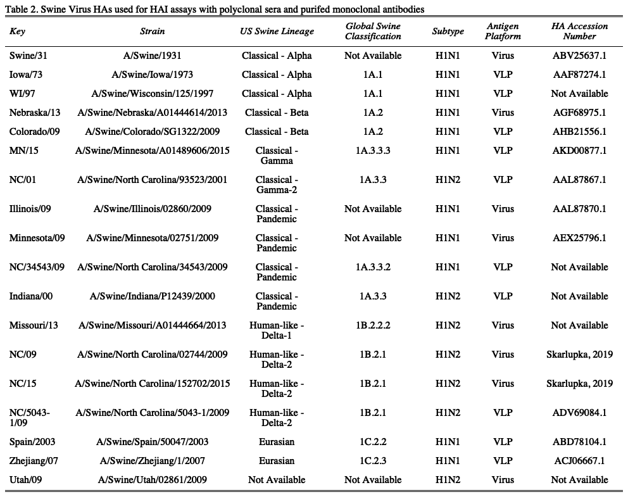

Figure 2: resulttable2.

#### Virus-like Particle (VLP) preparation

Human embryonic kidney 293T (HEK-293T) cells (1 x 10^6 cells total) were transiently transfected with 1 μg DNA of each of the three pTR600 mammalian expression vectors (Skarlupka et al., 2019) one of each expressing the influenza neuraminidase (A/Mallard/Alberta/24/2001; H7N3), the HIV p55 Gag sequence, and one of the various H1 wild-type hemagglutinins. Following 72 h of incubation at 37°C in serum free medium, transiently transfected cell supernatent was collected, centrifuged to remove cellular debris, and filtered through a 0.22 μm pore membrane. Virus-like particles (VLPs) were purified and sedimented by ultracentrifugation on a 20% glycerol cushion at 135,000 x g for 4 h at 4°C. VLPs were resuspended in phosphate buffered saline (PBS), and total protein concentration was determined with the Micro BCA Protein Assay Reagent kit (Pierce Biotechnology, Rockford, IL, USA). Hemagglutination activity (HA) of each preparation of VLP was determined by serially diluting volumes of VLPs and adding equal volume 0.8% turkey red blood cells (RBCs) (Lampire Biologicals, Pipersville, PA, USA) suspended in PBS to a V-bottom 96-well plate with a 30 min incubation at room temperature (RT). Prepared RBCs were stored at 4°C and used within 72 h. The highest dilution of VLP with full agglutination of RBCs was considered the endpoint HA titer.

#### Hemagglutination inhibition (HAI) assay

The hemagglutination inhibition (HAI) assay assessed functional antibodies specific to the HA able to inhibit agglutination of turkey erythrocytes. The protocol is adapted from the WHO laboratory influenza surveillance manual [1; REF]. HAIs were conducted with either polyclonal mouse sera or purified monoclonal antibodies. Polyclonal sera were treated with receptor-destroying enzyme (RDE) (Denka Seiken, Co., Japan) prior to being tested to inactivate nonspecific inhibitors. Briefly, three parts RDE were added to one part sera and incubated overnight at 37°C. RDE was inactivated by incubation at 56°C for ∼30 min. After heat treatment, six parts PBS were added to the RDE-treated sera. Purified monoclonal antibodies were adjusted to a concentration of 20 μg/ml in PBS.

RDE-treated and monoclonal antibodies were added in 50 μl to a V-bottom microtiter plate and were two-fold serially diluted across in PBS. An equal volume, 25 μl, of each virus (or VLP where applicable), adjusted to approximately 8 hemagglutination units (HAU)/50 μl, was added to all wells except for the last column which received 25 μl of PBS. The plates were covered and incubated at RT for 20 min. Then, 50 μl of 0.8% turkey red blood cells were added to each well. The plates were mixed by agitation and covered, and the RBCs were allowed to settle for 30 min at RT. The polyclonal sera HAI titer was determined by the reciprocal dilution of the last well that contained non-agglutinated RBCs. The monoclonal minimum agglutination concentration was determined by the dilution of the last well that contained non-agglutinated RBCs multiplied by the starting concentration of 20 μg/ml. Negative controls were included for each plate.All mice were negative (HAI < 1:10) for preexisting antibodies to currently circulating human and swine influenza viruses prior to vaccination.

#### Statistical Analysis

The limit of detection for the polyclonal sera HAI was 1:10, and 1:5 was used for the statistical analysis of samples below that. The limit of detection for the monoclonal antibody HAI was 10 ug/ml. Samples below that limit were defined as 20ug/ml for statistical analysis. The log2 geometric mean was calculated from the HAI titers of the polyclonal sera and monoclonal antibody concentrations.

# Results

### Data cleaning and Transformations

The data was imported from the raw excel data file along with the antigen and antibody keys.

Due to a limited supply of polyclonal sera, the HA inhibition was only determined for a representative swine virus from each lineage and clade. The monoclonal antibody HAI antigen panel included a wider range of antigens. Therefore, the HAs not included in the sera HAIs were removed from the sera analysis.

Variables were created based on the raw HAI titers for both the polyclonal sera and monoclonal antibodies. The polyclonal sera titer and monoclonal antibody conentration was transformed by log base 2. Furthermore, the monoclonal antibody dilution factor was determined by dividing 20ug/ml by the endpoint agglutination concentration.

## Univariate analysis

### Polyclonal sera analysis

Similar to the previous study between the COBRA antigens and HAI titers to swine viruses (Skarlupka et al., 2019), the P1 and CA/09 sera had differential reactions to the groups of different swine viruses (Figure 1). There were some viruses that had no HAI titer to such as NC/01, and MN/15. P1 sera had higher responses with respect to the Eurasian lineage viruses and three out of four classsical lineage viruses that exhibited inhibtion.

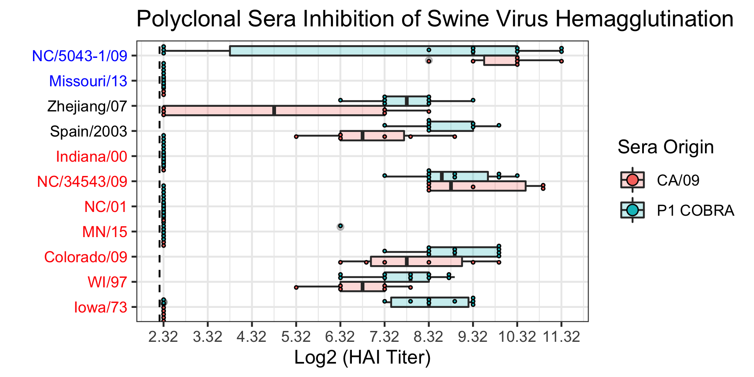

Figure 3: Figure 1. The HA inhibition of swine viruses of polyclonal sera of mice sub-lethally challenged with either A/California/07/2009 (CA/09) or P1 COBRA viruses. The swine virus panel included representatives from the classical (red), Eurasian (black), and human-like (blue) clades.

### A/California/07/2009 Monoclonal Analysis

Taking a look at the reponses based on the cross reactivity profiles of the monoclonals. There is no reactivity from the seasonal monoclonals and there is some reactivtity from the 1918 specific clones. The CA/09 specific ones had a higher titers and a wider response across more viruses compared to the other groups. Therefore, the CA/09 monoclonals are to be investigated further. 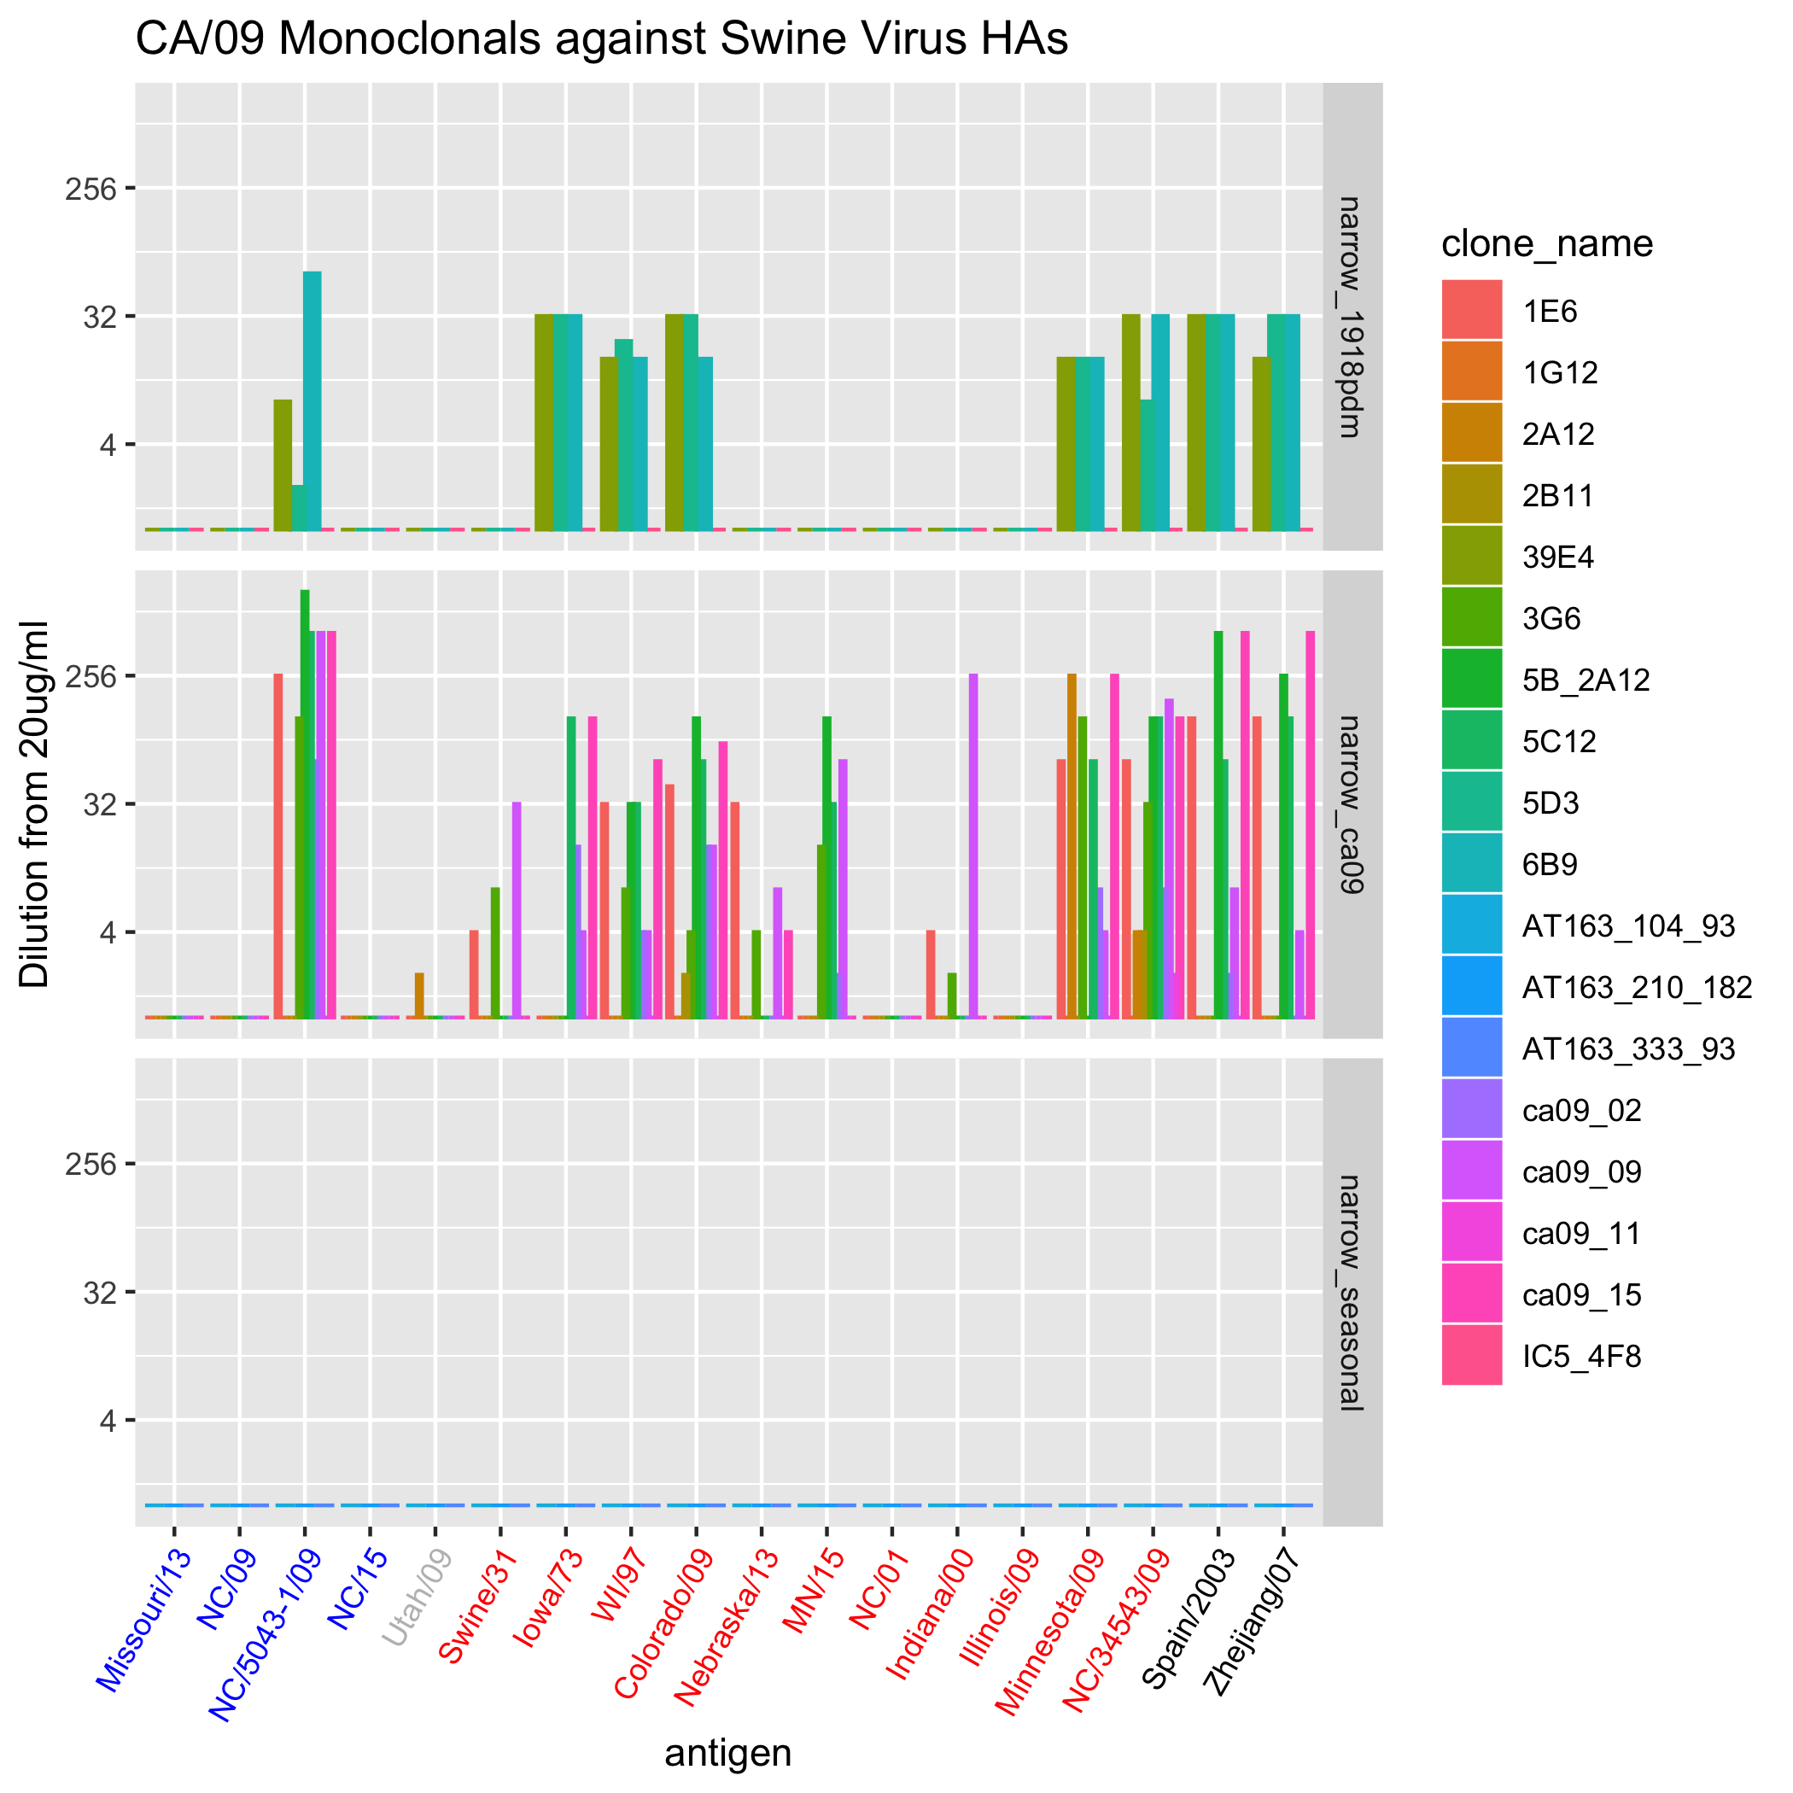

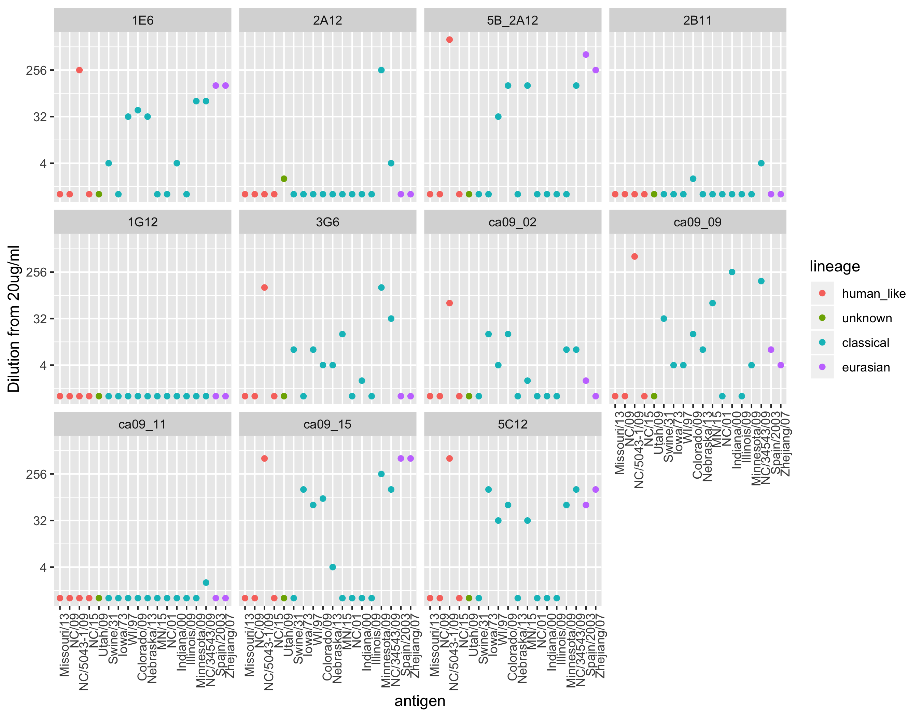

Figure 5: Figure 3.

### P1 Monoclonal Analysis

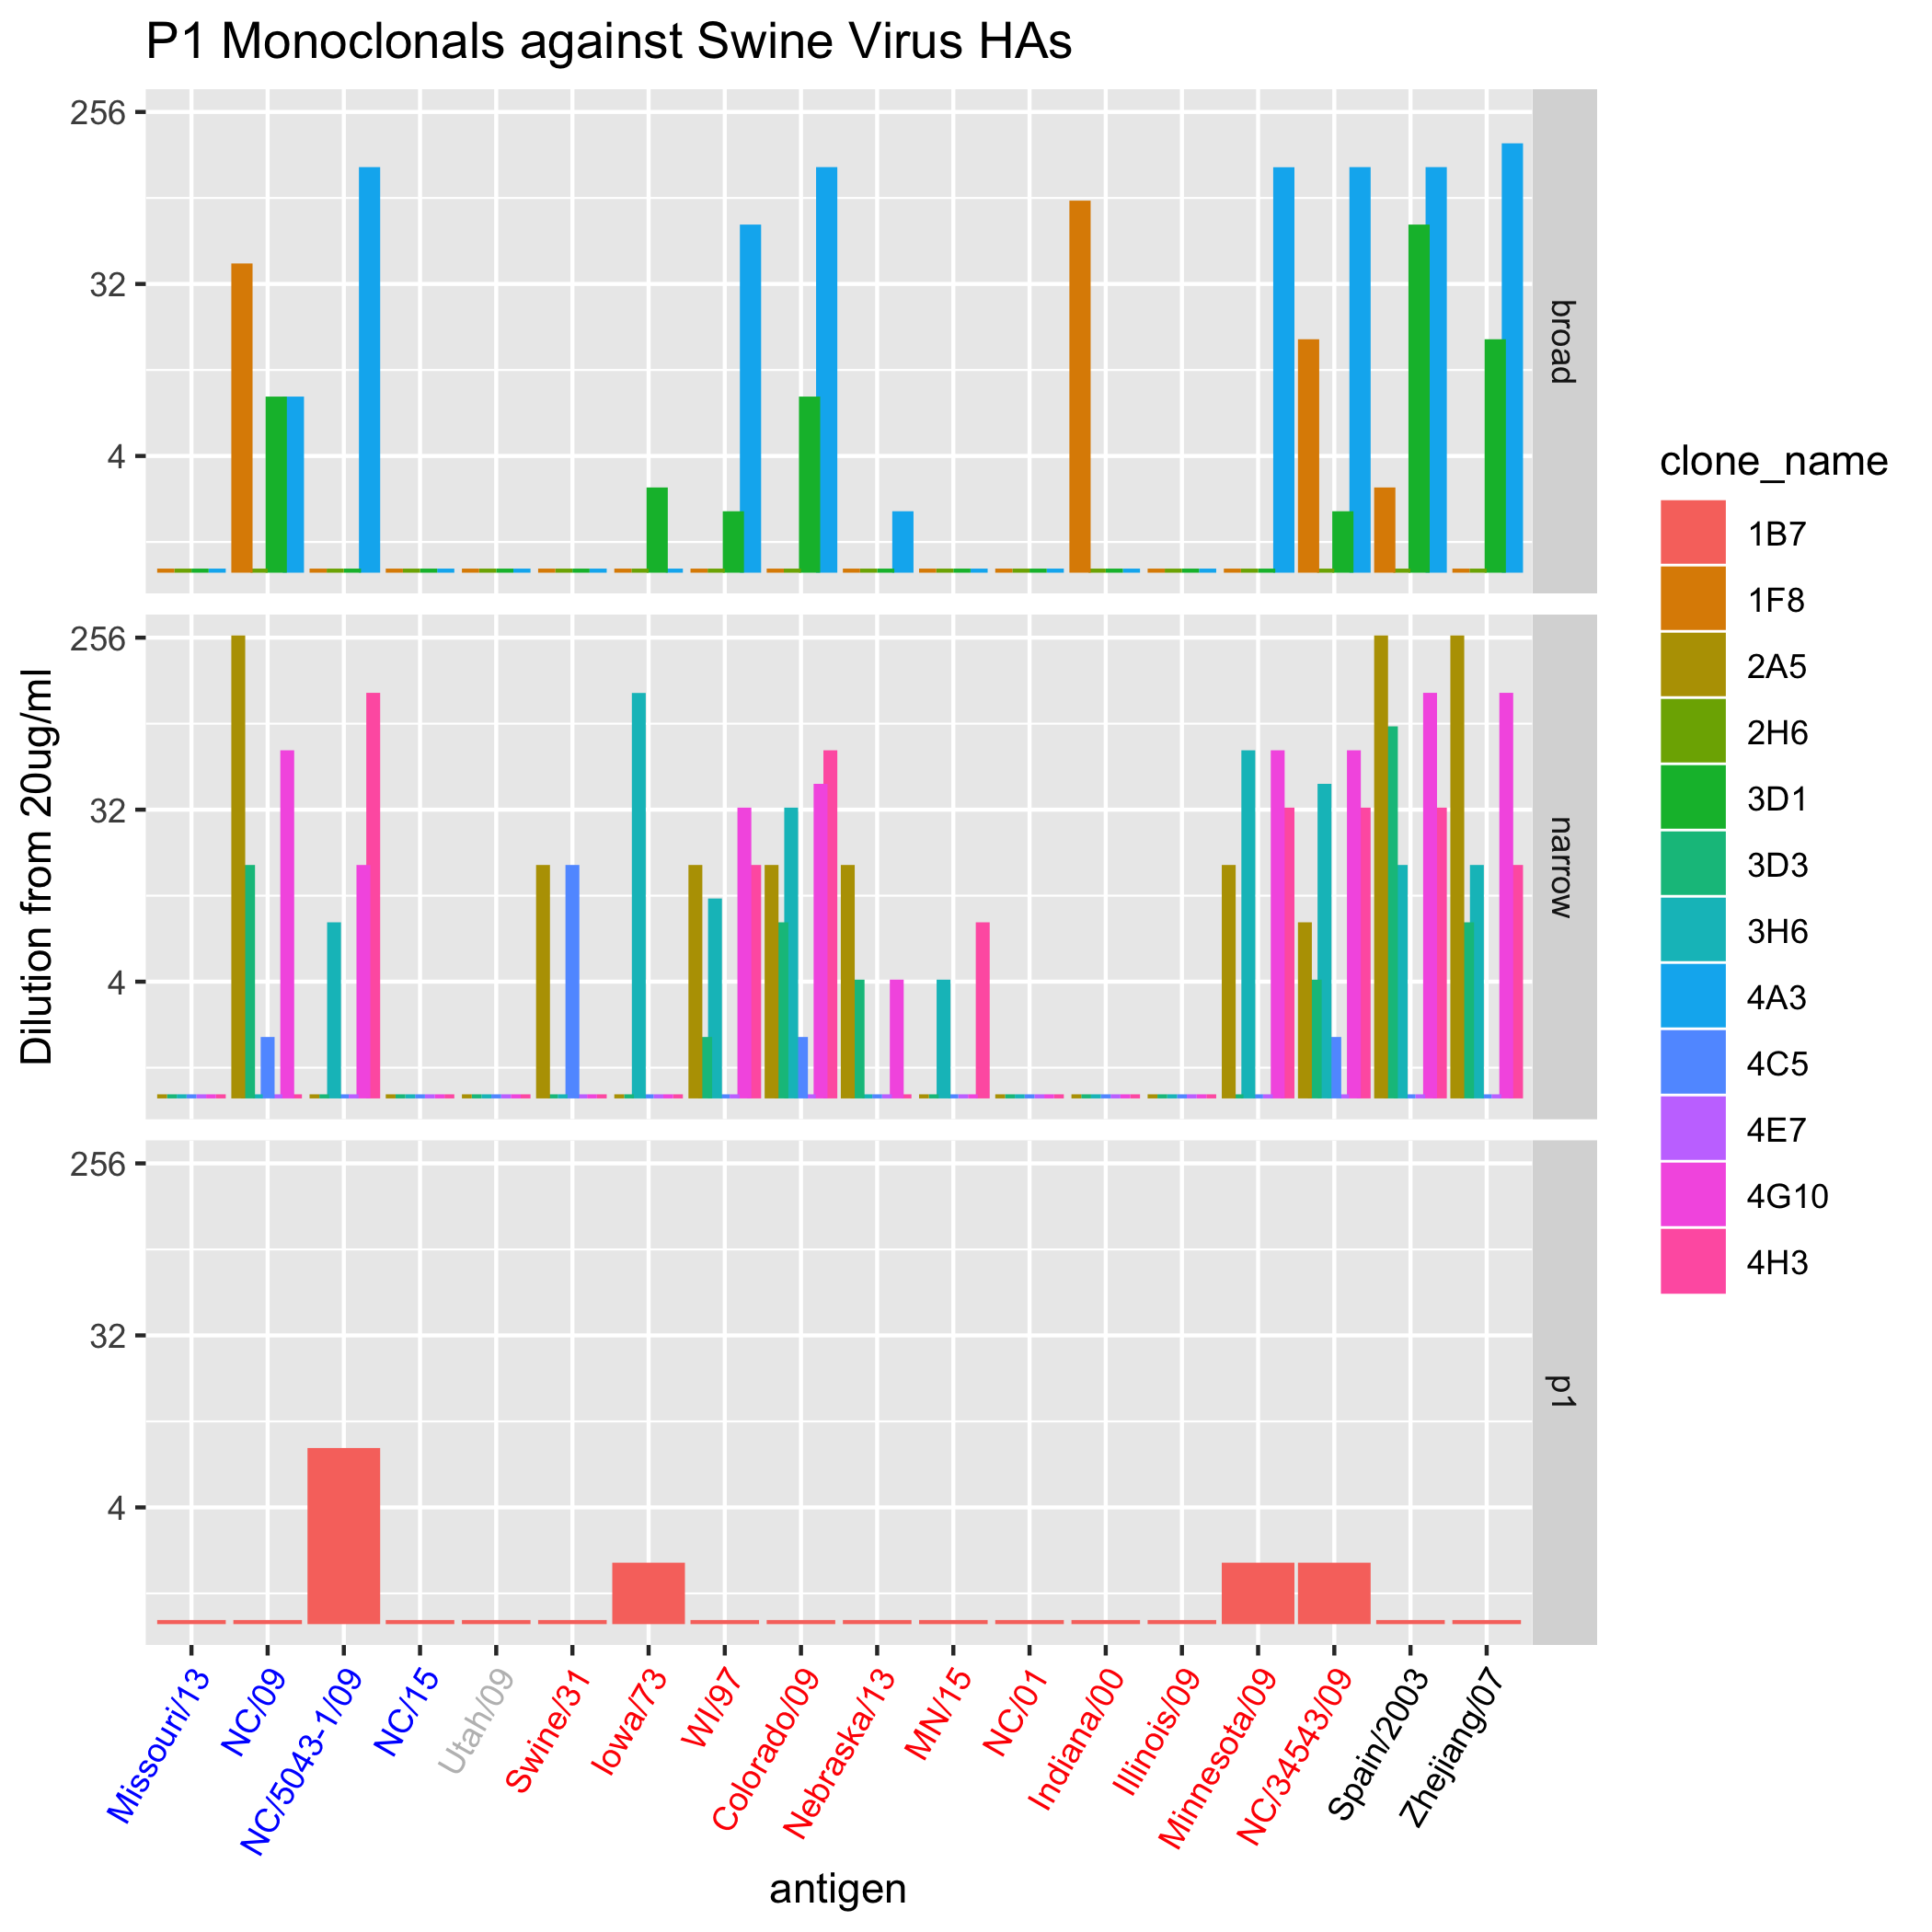 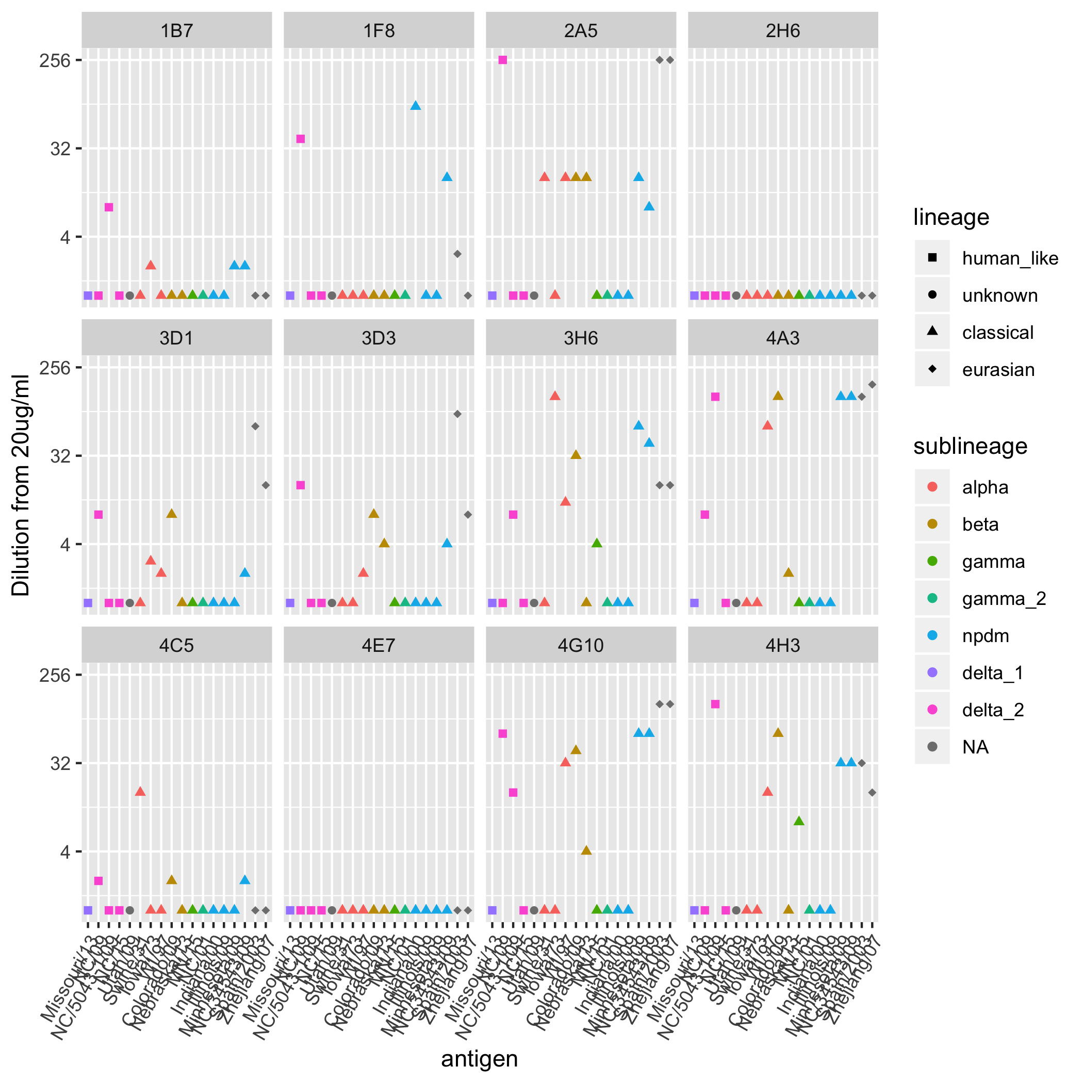

It looks as though there are some antigens that did not respond against any antibody. These HAs include Missouri/13, NorthCarolina/2015, and Illinois/2009. These will be removed from the radar plots because we want to look a little more indepth at the interactions between the positive results.



Figure 8: Figure 6. classical (red), Eurasian (black), and human-like (blue) clades.



Figure 9: Figure 7. classical (red), Eurasian (black), and human-like (blue) clades.

From looking at each virus separately

The questions that are being pursued here are: 1. What are the total number of viruses that each monoclonal inhibits the HA of?

A concentration of greater than 20, so just being recognized by the monoclonal antibody is what I’m considering to be inhibitory. The physiological relevant concentration is not known by me however.

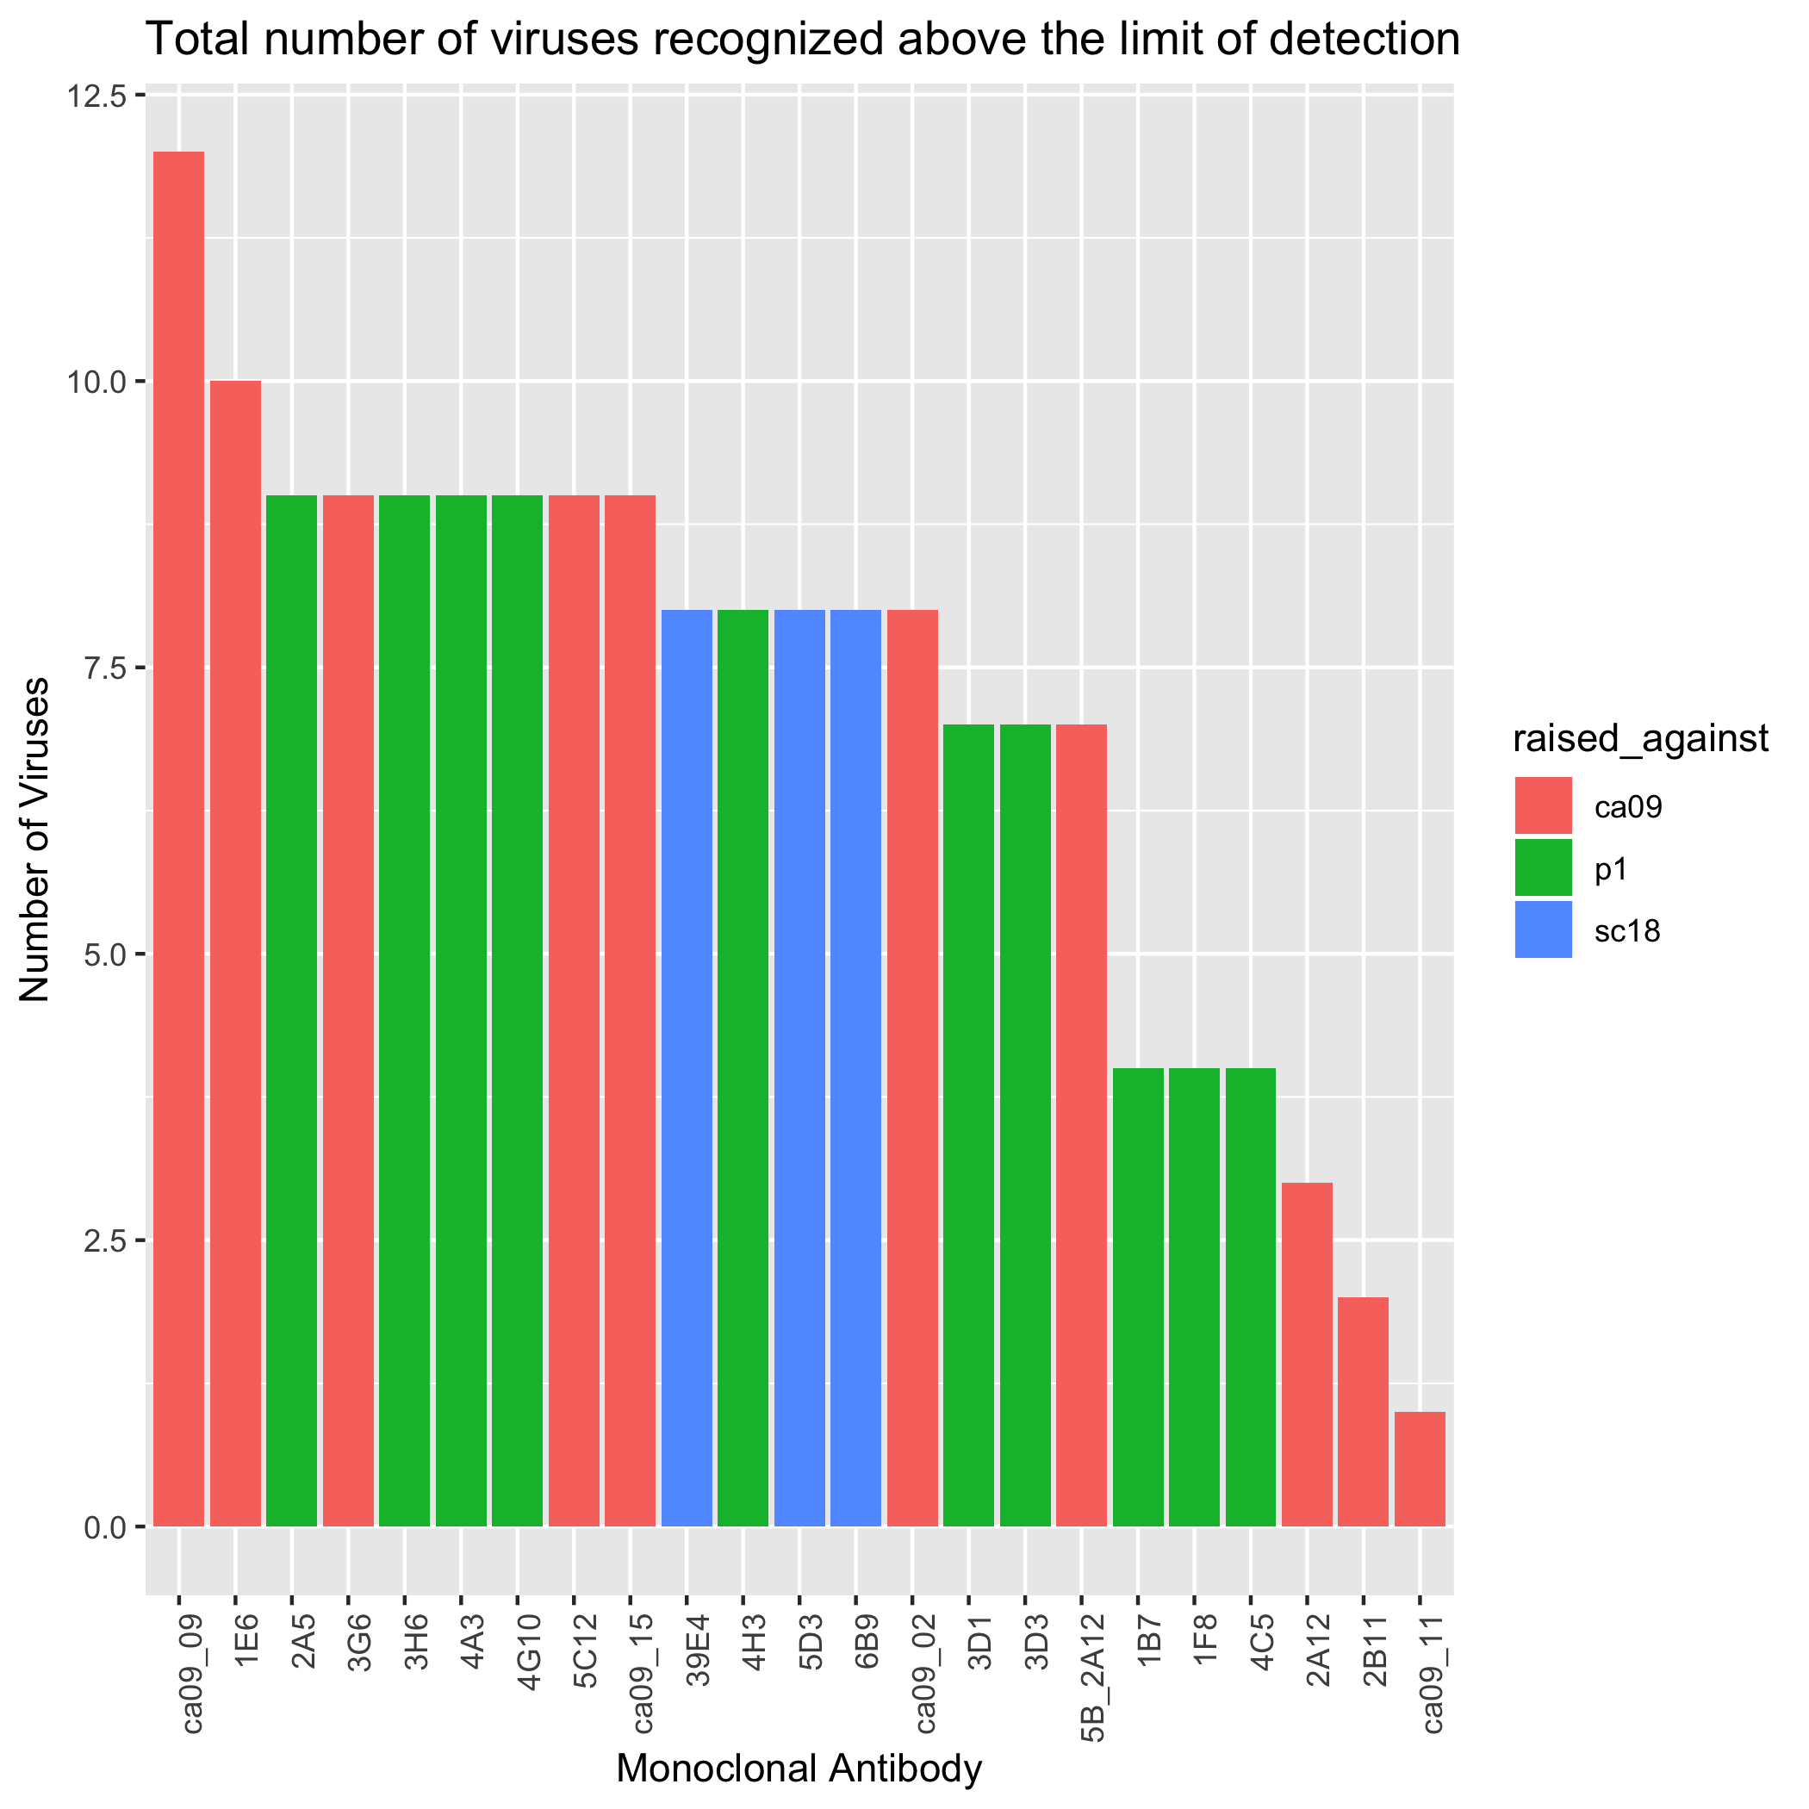 The P1 monoclonal antibodies recognized 13 out of 14 viruses, and the CA/09 antibodies recognized 13 out of 14 as well. There was one virus specific to P1 recognition (A/Swine/North Carolina/2009), and one virus specific to just CA/09 recognition (A/Swine/Utah/2009). The A/Swine/North Carolina/5043-1/2009 virus keeps falling within the same groups as the classical lineage viruses to the point where it is worrisome. I double checked the sequence in the lab used to make the virus-like particle and the classficiation of the virus with the literature and it confirmed that it is supposed to be in the human seasonal-like lineage.

## Bivariate analysis of P1 monoclonals compared to CA/09 monoclonals

To statistically take a look at my data I had two datasets that I was working with.

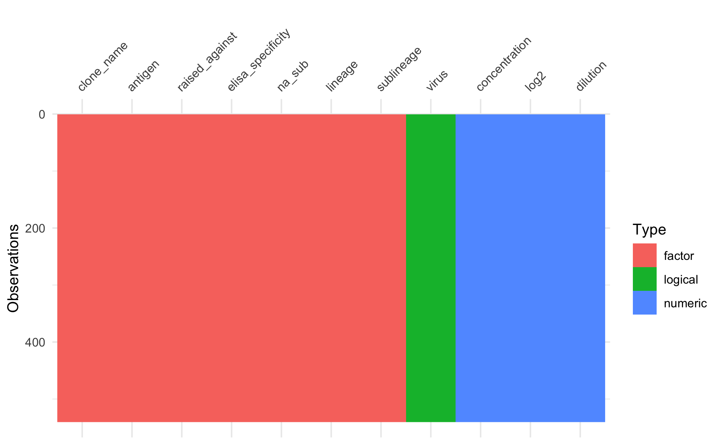

Figure 11: Figure 9. classical (red), Eurasian (black), and human-like (blue) clades.

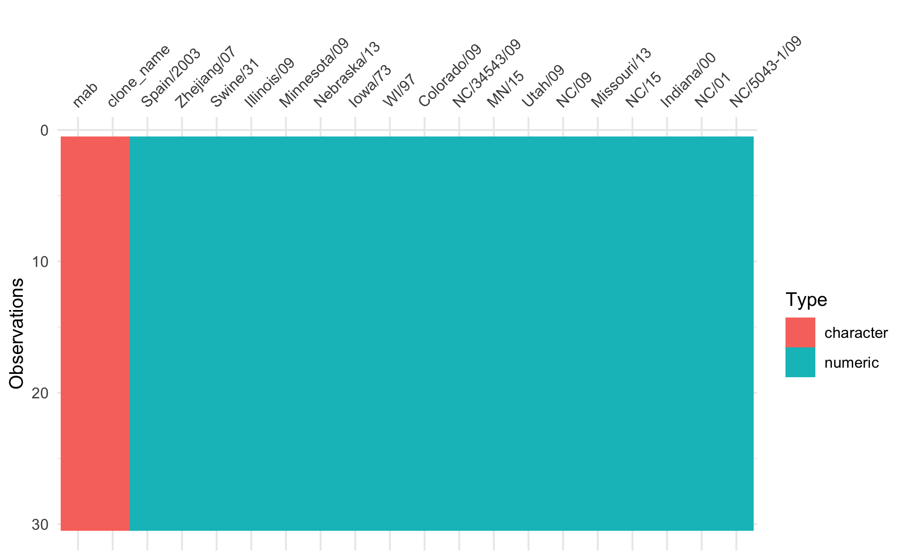

Figure 12: Figure 10. classical (red), Eurasian (black), and human-like (blue) clades.

The outcome variable is the origin of the monoclonal. I am interested in seeing if from the characteristics of the viruses if I can tell which monoclonal would react. Therefore the characteristics of the outcome variable is depicted in figure 11. The outcome variable is about equally weighted.

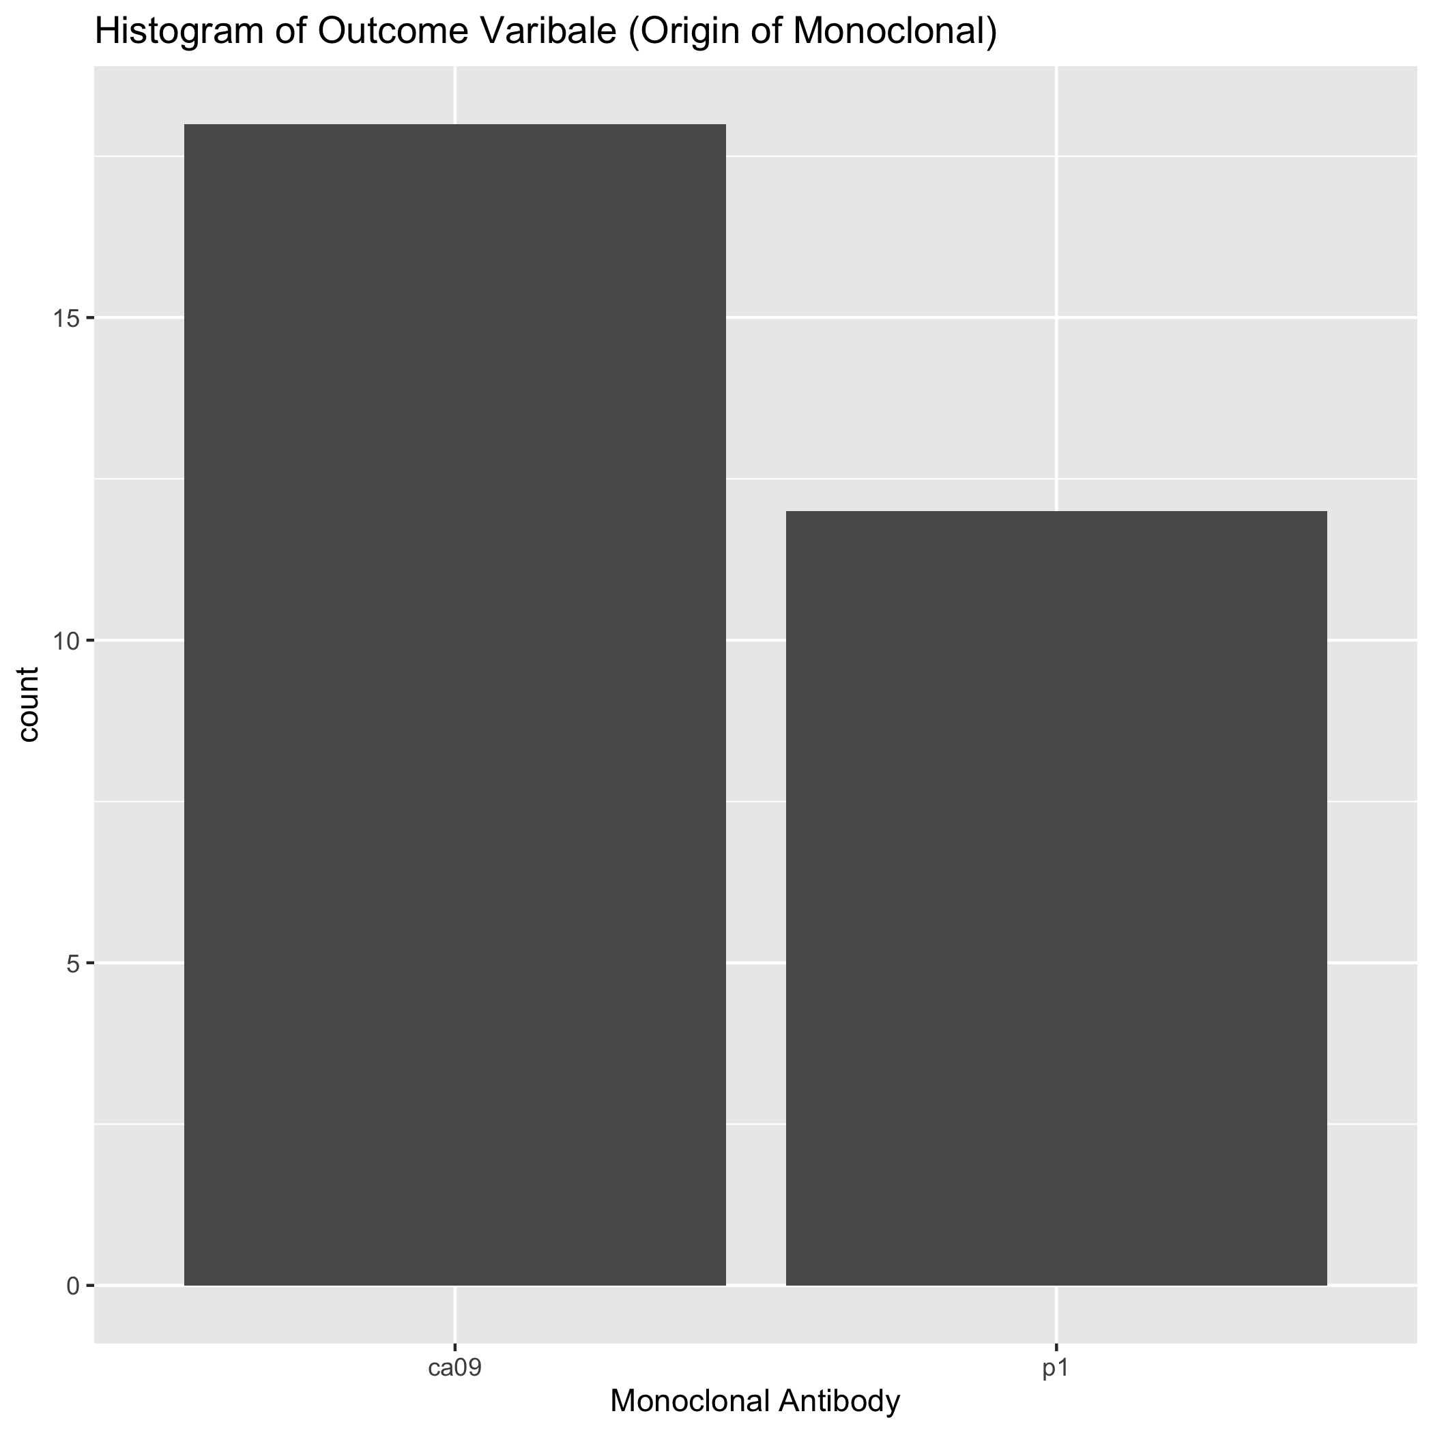

Figure 13: Figure 11. classical (red), Eurasian (black), and human-like (blue) clades.

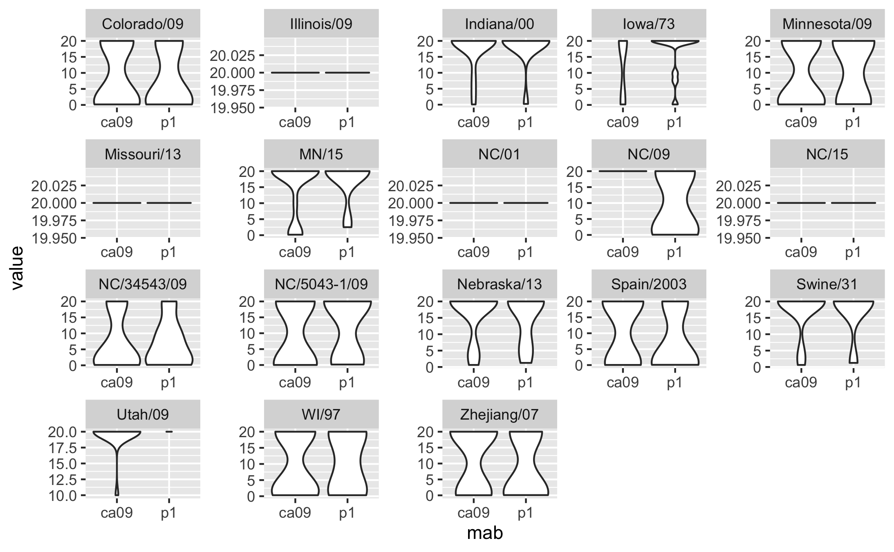

Figure 14: Figure 12. classical (red), Eurasian (black), and human-like (blue) clades.

The CA/09, P1, Bris/07, PR/34, and SC/18 titers were tested individually to confirm the assumption that the data is normally distributed in order to run a t-test between the data sets. However, the data failed the Shapiro-wilk test because the data (Tables 3 and 4).

##   
## Shapiro-Wilk normality test  
##   
## data: concentration[raised_against == "ca09"]  
## W = 0.64754, p-value < 2.2e-16

##   
## Shapiro-Wilk normality test  
##   
## data: concentration[raised_against == "p1"]  
## W = 0.63063, p-value < 2.2e-16

My data doesn’t pass the normality test. Therefore, it’s suggested to do a non-parametric Wilcoxon rank test instead of a t-test to determine if the groups are statistically significant. According the the Wilcoxon rank sum test, they are not.

##   
## Wilcoxon rank sum test with continuity correction  
##   
## data: ca09_conc and p1_conc  
## W = 20292, p-value = 0.2867  
## alternative hypothesis: true location shift is not equal to 0

The variances of the data were then confirmed to be similar.

##   
## F test to compare two variances  
##   
## data: concentration by raised_against  
## F = 0.96923, num df = 107, denom df = 107, p-value = 0.8719  
## alternative hypothesis: true ratio of variances is not equal to 1  
## 95 percent confidence interval:  
## 0.6621671 1.4186746  
## sample estimates:  
## ratio of variances   
## 0.9692263

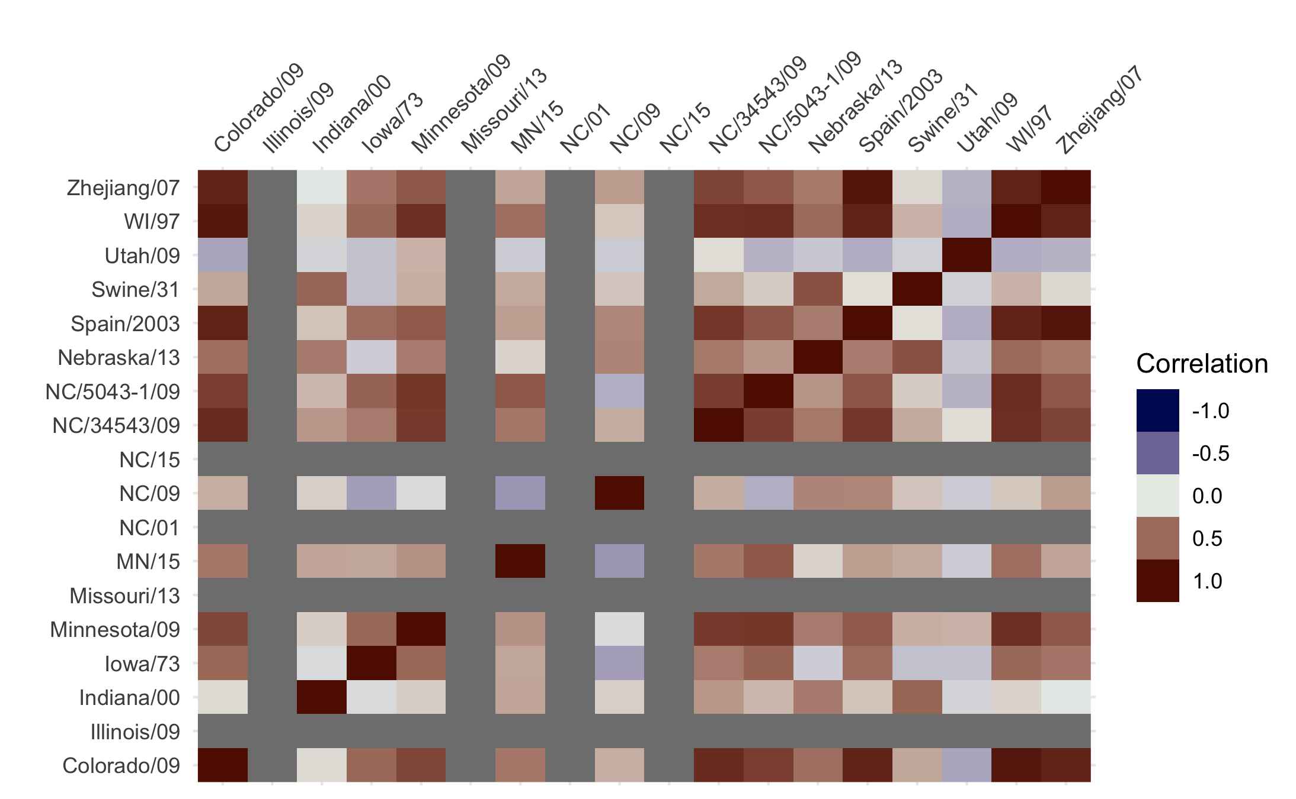 ### Single Predictor Model

The null model returns an ACC of 0.6 for the prediction of CA/09.

The single predictor model does not fair better than the null model (Table 7). So it looks like only one of the single predictor models have a higher accuracy than the null. That one is the NC/09 HA with a value of 0.833.

|  |  |
| --- | --- |
| variable | Accuracy |
| Spain/2003 | 0.4866667 |
| Zhejiang/07 | 0.4800000 |
| Swine/31 | 0.5200000 |
| Illinois/09 | 0.6000000 |
| Minnesota/09 | 0.5466667 |
| Nebraska/13 | 0.5133333 |
| Iowa/73 | 0.4466667 |
| WI/97 | 0.4733333 |
| Colorado/09 | 0.5333333 |
| NC/34543/09 | 0.4733333 |
| MN/15 | 0.5600000 |
| Utah/09 | 0.6000000 |
| NC/09 | 0.8333333 |
| Missouri/13 | 0.5600000 |
| NC/15 | 0.5800000 |
| Indiana/00 | 0.5333333 |
| NC/01 | 0.6000000 |
| NC/5043-1/09 | 0.5266667 |

When a full logistic model was ran with all of the predictors the accuracy was still equivalent to 0.6 (supplementary table 1). The subset modelling (with 100 iterations) returned some models with higher accuracy (Table 8).

|  |  |  |
| --- | --- | --- |
| method | Accuracy | Model |
| sbs | 0.7933333 | spain_03, mn_09, ne_13, ia_73, wi_97, ut_09, nc_09, nc_5043_09 |
| sfbs | 0.7866667 | spain_03, mn_09, ia_73, wi_97, ut_09, nc_09, in_09 |
| sfs | 0.8333333 | nc_09 |
| sffs | 0.8333333 | spain_03, nc_09 |
| GA | 0.8400000 | swine_31, il_09, ne_13, co_09, ut_09, nc_09, nc_5043_09 |

They were all greater than the full and null model of 0.6.

## Full analysis

### Tree Analysis

The previous analysis only looked at the titers of the monoclonals. But by looking at the other charateristics we may be able to determine more about the data. The other variables were compared to the outcome variables of which virus the monoclonals were raised against (Figure 14). All of the differnent variables are visualized in Supplemental Figure 9. This is not a binomial outcome because there are five different outcomes. Therefore I will try to make a decision tree of the variables.

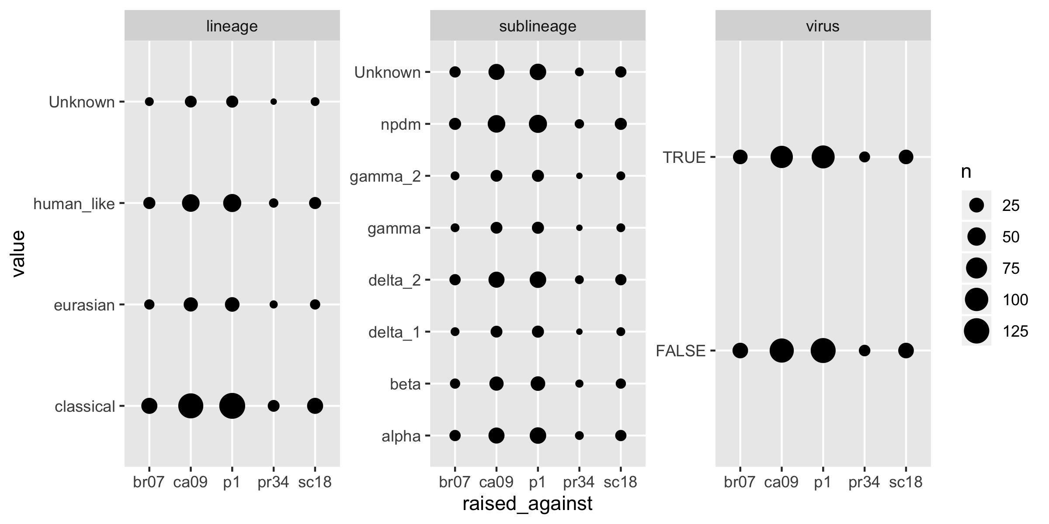

Figure 16: Figure 14. classical (red), Eurasian (black), and human-like (blue) clades.

We know from above that the null model accuracy of predicting P1 (the greatest value) is 0.4 (216/540 total observations).

The single predictor analysis is described in table 9. Some of concentration, log2, and dilution ( which are just transformations of each other) have about the same accuracy of 0.44, marginally better than the null.

## Variable Accuracy  
## 1 concentration 0.4462823  
## 2 log2 0.4402666  
## 3 dilution 0.4466831  
## 4 virus 0.4000262  
## 5 na_sub 0.3907407  
## 6 lineage 0.3753044  
## 7 sublineage 0.3400843

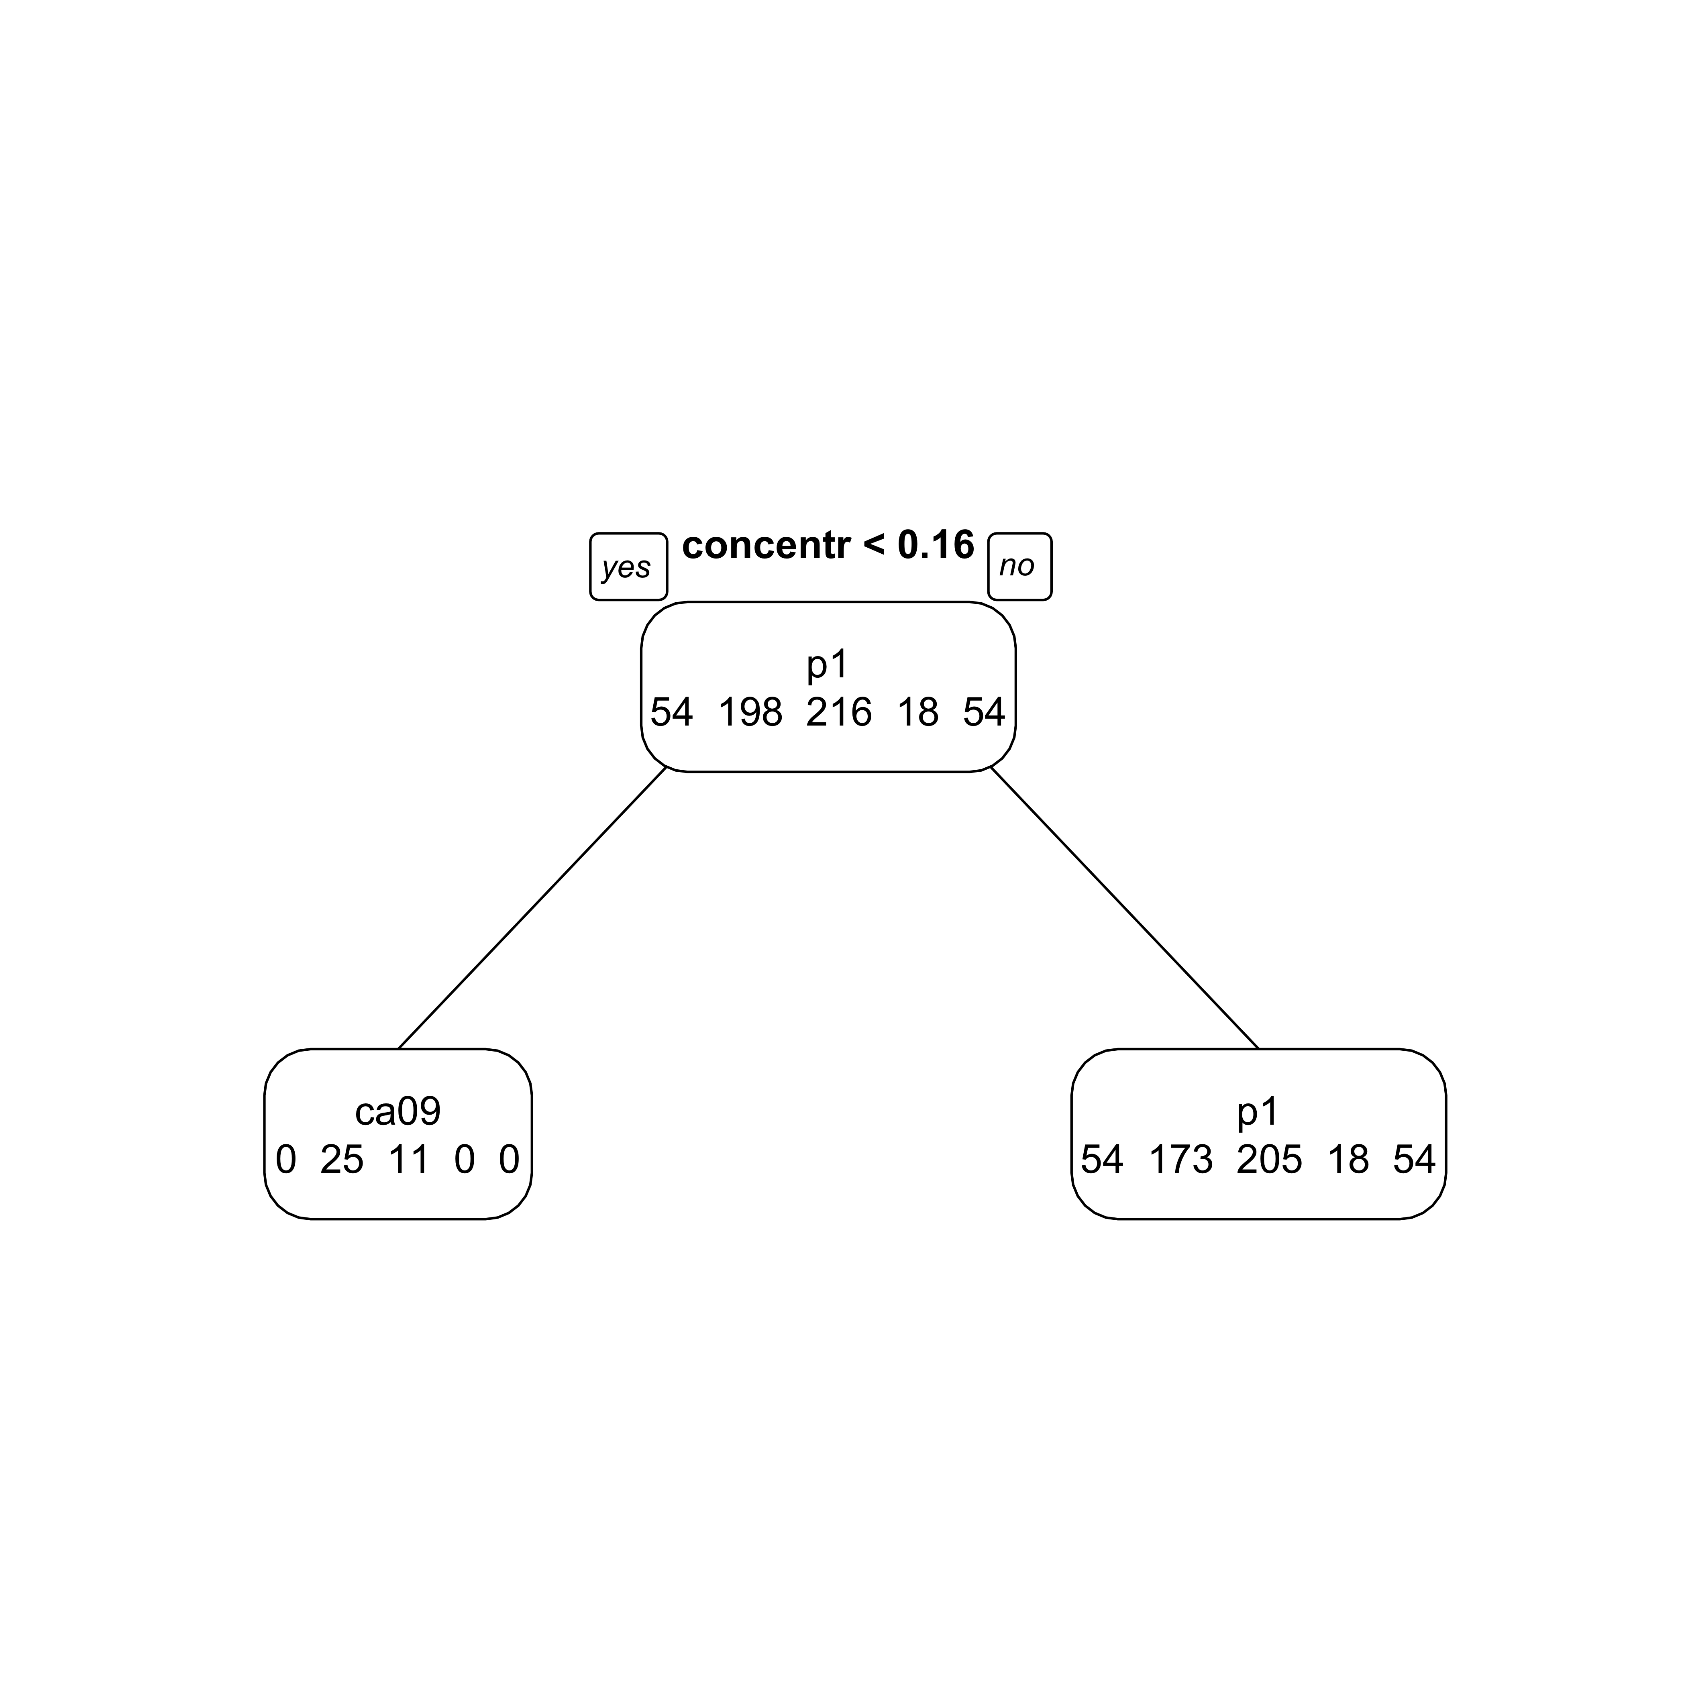 I don’t think I have enough data for a tree.

### Principal component analysis

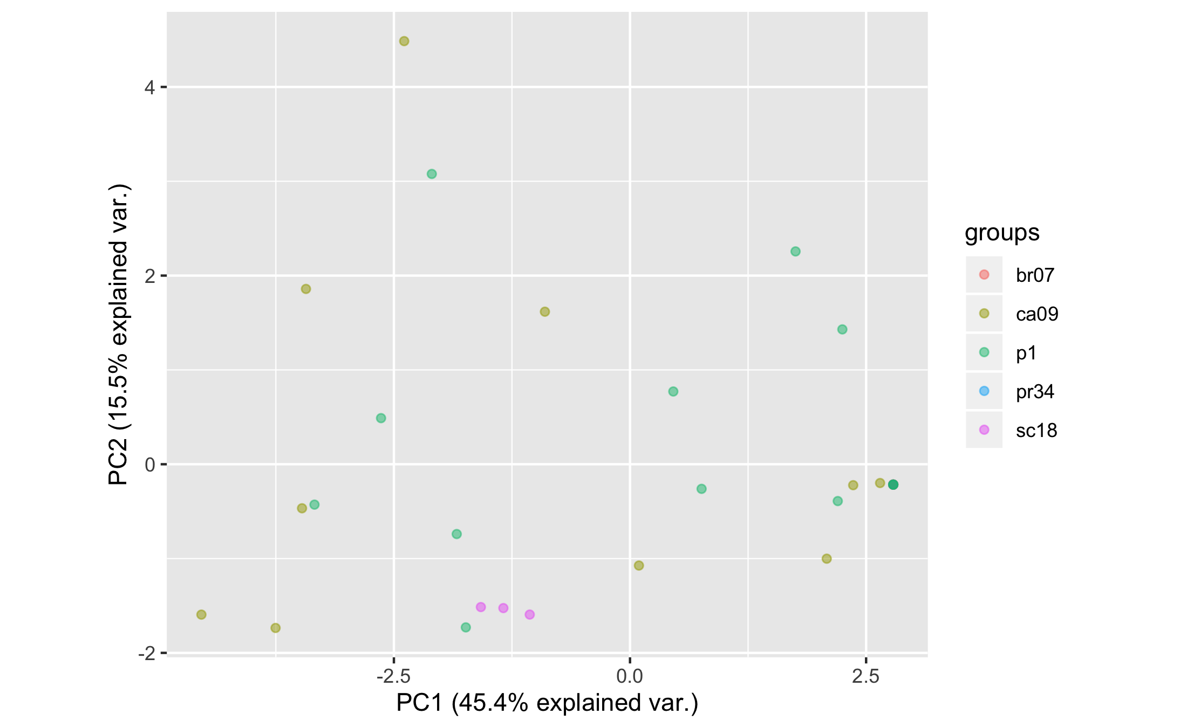 The supplementary figure 6 also contains the PCA analysis of the sera responses.

# Discussion

## Summary and Interpretation

*Summarize what you did, what you found and what it means.*

## Strengths and L imitations

*Discuss what you perceive as strengths and limitations of your analysis.*

## Conclusions

*What are the main take-home messages?*

*Include citations in your Rmd file using bibtex, the list of references will automatically be placed at the end*

# References

Anderson, T. K., Campbell, B. A., Nelson, M. I., Lewis, N. S., Janas-Martindale, A., Killian, M. L., & Vincent, A. L. (2015). Characterization of co-circulating swine influenza A viruses in North America and the identification of a novel H1 genetic clade with antigenic significance. *Virus Res*, *201*, 24–31. <https://doi.org/10.1016/j.virusres.2015.02.009>

Anderson, T. K., Macken, C. A., Lewis, N. S., Scheuermann, R. H., Van Reeth, K., Brown, I. H., … Vincent, A. L. (2016). A Phylogeny-Based Global Nomenclature System and Automated Annotation Tool for H1 Hemagglutinin Genes from Swine Influenza A Viruses. *mSphere*, *1*(6). <https://doi.org/10.1128/mSphere.00275-16>

Anderson, T. K., Nelson, M. I., Kitikoon, P., Swenson, S. L., Korslund, J. A., & Vincent, A. L. (2013). Population dynamics of co-circulating swine influenza A viruses in the United States from 2009 to 2012. *Influenza and Other Respiratory Viruses*, *7*(S4), 42–51.

Skarlupka, A. L., Owino, S. O., Suzuki-Williams, L. P., Crevar, C. J., Carter, D. M., & Ross, T. M. (2019). Computationally Optimized Broadly Reactive Vaccine Based Upon Swine H1N1 Influenza Hemagglutinin Sequences Protects against both Swine and Human Isolated Viruses. *Hum Vaccin Immunother*. <https://doi.org/10.1080/21645515.2019.1653743>